JAVA Homework #4 (Due Nov 15 Friday)

1. Make a calculator, which can perform that by combining a continuous sequence of digit as a number and a single character operator(+,-,\*,/) as a operator token.

* If parentheses are available, you get a bonus score.

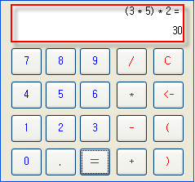

You can change the form of the calculator. But, it must contain all functions.

<test case>

2-3 = -1

2+3-5 = 0.0

2/3 = 0.6666666666666666

2+3\*3 = 15

<bonus score>

2+(3\*3) = 11

2\*(3+3) = 12

Each student must use the package name as hw4.

Class name is ‘s+student id+hw4.java’.

For example, if a student’s id number is 2017xxxx, the file name(class name) becomes s2017xxxxhw4.java.

You should submit source code through email: younmin.bae94@gmail.com